**STRATHMORE UNIVERSITY**

**Diploma in Business Information Technology**

PROJECT TITLE: Student Personal Assistant



Student name: **ABDALLAH, Mohammad Abdulkarim**

Student number: **99753**

Submitted to the Faculty of Information technology

Date of Submission: **June 2018**

DECLARATION

I MOHAMMAD ABDULKARIM ABDALLAH declare that this work has not been previously submitted and approved for the award of a diploma by this or any other University. To the best of my knowledge and belief, the research proposal contains no material previously published or written by another person except where due reference is made in the research proposal itself.

Student Name: ABDALLAH, Mohammad Abdulkarim

Sign: _______________________________________

Supervisor’s name: Tiberius Tabulu

Sign: _______________________________________

Table of Contents

DECLARATION 2

ABSTRACT 4

LIST OF FIGURES 5

LIST OF TABLES 5

ABBREVIATIONS 6

CHAPTER 1: INTRODUCTION 7

1.1 Background of the Study 7

1.2 Problem Statement 8

1.3 Research objectives 8

1.4 Research questions 8

1.5 Scope 9

1.6 Justification/significance of the study 9

1.7 Limitations and delimitations 9

CHAPTER 2: LITERATURE REVIEW 10

2.1 General overview of chapter 10

2.2 Supporting Technologies and Services 10

2.3 Related Works 11

2.4 Problems and Challenges 15

2.5 Gaps and solutions 16

2.6 Conceptual framework 17

CHAPTER 3: RESEARCH METHODOLOGY 18

3.1 Introduction 18

3.2 System Development Methodology 18

3.3 Justification of the methodology 19

3.4 Functional and Non-functional Requirements 19

3.5 Tools and techniques to be applied 20

3.6 Project Milestones and Deliverables 21

3.7 Gantt chart 22

References 23

ABSTRACT

The following is a proposal for a student personal assistant/organizer, nicknamed “Organ Eyes.” The project aims at aiding students through software to organize themselves appropriately in an academic setting, to boost productivity among students, consequently improving academic performance and discipline among students.

The application will be mobile based and will run on the Android Operating System as its primary platform. Limitations that might be faced include its restricted nature in terms of the platform it will support as well as watered down features due to time constraint.

The project will be developed using the Prototyping methodology (specifically “selected features” prototyping).

Functional requirements of the project include: creating schedules for study as well as timetables, creating reminders for deadlines and assignments and expenditure tracking. A budget planner will also be included to help students set targets as to how much they want to be spending per week. Milestones to be set by the students can also be noted down by the users and progress tracked.

As the software is being developed on android the primary programming language to be used will be Java, and the approach to be Object-Oriented Programming paradigm.

LIST OF FIGURES

Figure 1: Evernote Logo 11

Figure 2: Evernote Basic layout (Sexton, 2017) 12

Figure 3: Google Keep Logo 13

Figure 4: Google Keep Layout 13

Figure 5: Google Calendar Logo 14

Figure 6: Google Calendar Layout (from my personal Google Calendar) 15

Figure 7: Conceptual Freamework (made with LibreOffice) 17

# LIST OF TABLES

Table 1: List of tools to be used 19

Table 2: List of techniques to be used in this project 20

ABBREVIATIONS

The following abbreviations are repetitively used throughout this document and are to be taken to mean the following:

1. OS- Operating System
2. API- Application Programming Interface
3. GUI- Graphical User Interface
4. SDK- Software Development Kit
5. IDE- Integrated Development Environment
6. App- Application (Software)
7. Sync- Synchronize
8. OOP- Object Oriented Programming
9. IQ- Intelligence Quotient

CHAPTER 1: INTRODUCTION

* 1. Background of the Study

The following proposed software is a Student Personal Assistant and planner, which has been nicknamed “**Organ Eyes**” (from the word “*organize*”, which is essentially the purpose of the app).

The app will be developed primarily with the students in mind, as an aid and assistant in their daily academic lives. The student in this case will primarily be the undergraduate student, however other levels of education can benefit from the app as well (such as postgraduate and high school).

The app intends to aid the students to increase their productivity levels through various methods. It will intend to permeate the student’s academic life and digitize the whole process of day-to-day activities which the student undertakes. It will do this in various ways to be discussed below.

In a certain study, the top three steps to follow for students to increase productivity were determined to be: Actions, Information and Visualizing. (DAlessio, 2018).

Actions involved keeping tasks up to date and deadline assignment to these tasks. Information involved keeping one’s resources nearby always. This includes, classes, meetings, events, PDF notes, other documents and many others and finally visualization involved having a calendar, to aid the students in seeing (visualizing) anything coming up to better prepare for them.

Relevant to this app, another study lists tracking time, setting deadlines for oneself, planning and grouping errands as some of the top tips to increase one’s productivity (Sabell, 2017).

Organ Eyes plans to hopefully integrate all if not most of these features into one, student-focused app, to increase the students’ overall productivity.

It is worth noting that this app is not a planner app or note taking app but rather a student aid and guide as will be demonstrated in detail below.

* 1. Problem Statement

It has been noticed that many students suffer from varying degrees of inefficiency. This is caused partly due to self-disorganization (a lack of a proper plan and routine, student being spontaneous in tackling most academic tasks) and partly due to the lack of appropriate software to aid the students to organize themselves.

Among the issues many students face, whether at university level or School include: persistent lateness for classes, failure to commit to deadlines for assignments, very poor/inefficient and hence unnecessarily costly spending habits, among others.

There is an apparent lack of a single, integrated piece of software that is primarily student-focused. The following project, nicknamed “Organ Eyes” aims to do just that. It will attempt to encourage a sense of organization in students by harmonizing most of what surrounds their academic lives into one application.

* 1. Research objectives

1. To investigate inefficiency among students and the impact it has on them.
2. To evaluate existing systems along with their limitations
3. To design a mobile based solution
4. To Develop the solution
5. Test the solution
   1. Research questions
6. How do students cope with time management and how has inefficiency impacted their academic performance?
7. Do students make use of existing software? Is the existing software suitable and helpful to students?
8. Which is the most suitable platform to develop the system on?
9. Does the system function as expected?
   1. Scope

The intended software will be developed as a mobile application. Specifically, it shall be developed for the Android OS. This appears to be the most popular operating system for most students and users in general (Computer Hope, 2018), hence is meant to account for the majority. The usages of this application also suggest that the target users be constantly using the application hence the quickest means to do so would be via a mobile application rather than a web-based application or desktop application.

* 1. Justification/significance of the study

The software is intended to increase student productivity, resulting to better performances from the students in general. If the application is seriously used by students at any academic level results are bound to be noticed in terms of productivity improvements as well as self-organization. In turn students will find themselves having easier times in planning their study and deadlines and could consequently lead to better academic performance.

Students need to set goals along with deadlines as a way of boosting productivity (Chua, 2018).

Aside from academic improvement it also serves as a disciplining tool for the students and hence aiding in character formation, as an unintended but inherent extra benefit. Once students gain assistance from the application in arriving to classes on time, through constant reminders, organizing all their notes and files in one location, proper budgeting and spending habits among others, these small but virtuous habits will hopefully permeate into other aspects of the students’ lives.

* 1. Limitations and delimitations

The application is bound to face some of the following unavoidable/obvious limitations:

1. The application, at the time of development, will only be supported on one platform, that is the Android OS. Thus, users on other platforms such as Windows (PC and Phone), iOS (Mobile), Mac OS, Linux Distributions will be left out.
2. Users of the app may not be able to sync their documents and folders across devices for uniformity and portability. This is due to limited development time as the app is meant to be a prototype, and is strictly mobile-based hence no web access.

CHAPTER 2: LITERATURE REVIEW

2. 1. General overview of chapter

In this chapter, various aspects to do with the viability and importance of the proposed system will be discussed.

Supporting technologies and services will be stated and expounded upon for extra clarity. Problems and challenges that the users face will be addressed and discussed in more detail, in line with the objectives listed in chapter 1. Gaps existing will be discussed as well as solutions to these problems with regards to what the software must offer.

In addition, related works, in which any existing systems and software will be discussed. The functionalities of these systems will be addressed, as well as the deficiencies which necessitate the development of the proposed project.

Finally, to summarize the entire proposed system’s functionality and layout, a concept diagram will be appended to give a visual representation of how the intended software will come into place.

* 1. Supporting Technologies and Services
  2. Related Works

It is worth noting the software listed below have been listed so due to their popularity and relevance to the mobile-based platform. Other software apps may exist that serve the same or similar functions, for example Microsoft’s OneNote and other applications.

The following alternatives exist, together with their limitations:

1. Evernote

Figure 1: Evernote Logo

Evernote is essentially a full-blown planner and note taker. One of the oldest in the market, it has evolved from simple basic note taking to an all in one planner. It is a cloud-based cross platform software, meaning it can be used on multiple devices and synced across all other devices for enhanced portability. It runs on multiple platforms: Web-based (Evernote online), Android OS, iOS and Windows.

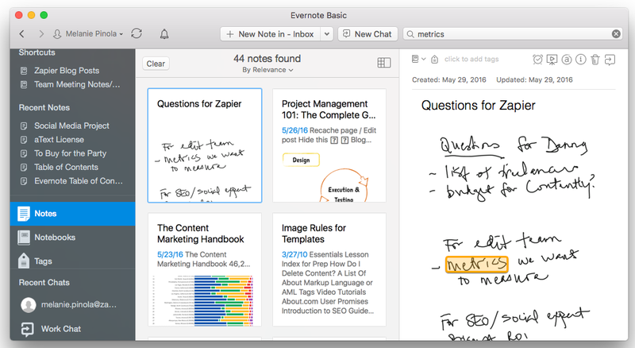

Figure 2: Evernote Basic layout (Sexton, 2017)

Evernote provides a notebook for users to take down notes. It also allows for checklists, attachments, tables and tagging features. It has a text searcher that can look for text in both typed form and in images. It allows for note clipping from websites using certain browsers (Chrome, Safari, Firefox and Opera). It also allows users to save emails to the application by forwarding them to a special Evernote email address. Users can also create ink notes (hand-written notes). In addition, Evernote allows users to upload images and videos too.

However, there are some limitations. A lot of the features are inaccessible for the free version, which only allows 60 MB of cloud storage. Anything extra requires users to subscribe with a monthly payment of $ 3.99 up to $ 7.99 monthly. The amount subscribed is what will determine the number of features available for use. In addition, the app does not have any “Student features.” They are all general and more focused for personal projects rather than “plans”.

1. Google Keep

Figure 3: Google Keep Logo

Google keep is a more simplified form of the Evernote app. It is Web-based as well as mobile based. It also provides syncing across devices and cloud storage for those with a google account. The advantage it has over Evernote is that it is completely free. However, it is not readily available across as many platforms and has fewer trimmed down features. (Gildred, 2018)

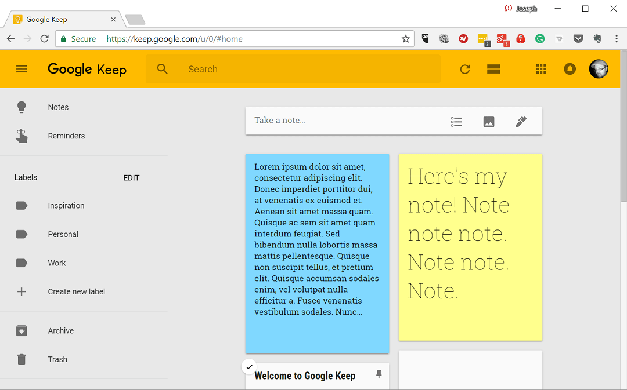

Figure 4: Google Keep Layout

It is useful for simple notes, lists and reminders. It allows users to attach images to notes (but not store on cloud). It is very useful for basic usage.

However, as with Evernote, it lacks the student-focus. It cannot help students keep track of expenses and budget. It is worth noting Google does provides all these services via other apps (such as Calendar and Drive). Nevertheless, they lack an integration into one fully fledged application to meet student needs.

1. Google Calendar

Figure 5: Google Calendar Logo

Google calendar is the most popular calendar and event organizer on the android OS as well as web-based platform. It also requires users to have a Google account hence can be used in sync with Google Keep. In fact, reminders on Google Keep are automatically synced on Google Calendar as well.

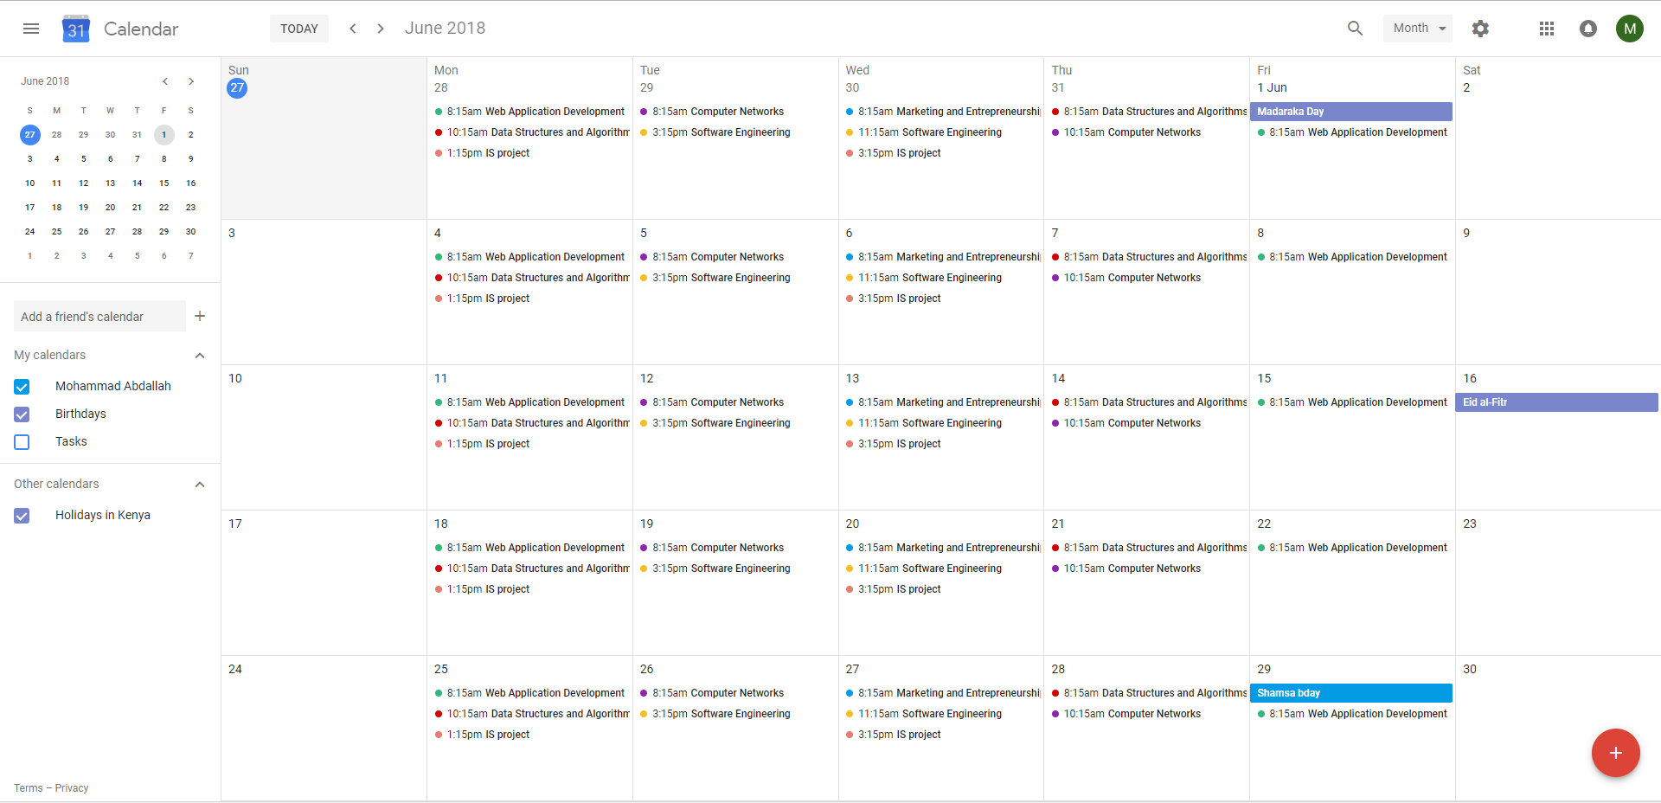

Figure 6: Google Calendar Layout (from my personal Google Calendar)

The app primarily allows users to create events and reminders. For students these events could be classes that the students are taking along with their location, frequency and any extra information. Google Calendar also allows users to create multiple calendars for various situations such as home and work (Karch, 2018).

* 1. Problems and Challenges

Various students at various academic levels, be it primary school, high-school or university suffer from disorganization. This same disorganization in turn leads to high rates of inefficiency among students. These students do not exert themselves as much as they should, or could. In turn they end up performing poorly academically (according to their standards), or maintaining a mediocre level of performance (Duckworth, 2012). All these challenges impede academic performance among students that could, or should be doing much better.

Some students have various issues including adhering to assignment deadlines, persistent lateness for classes and bad spending habits. All these are challenges faced by the user.

* 1. Gaps and solutions

To develop an application that will aid in improving student efficiency academically, and in turn improve academic performance. Improving student efficiency consequently improves student discipline which results in better academic performance among students.

A study by the University of Pennsylvania shows that highly self-disciplined adolescent students outperformed the more intelligent (high IQ) but less disciplined students on every academic-performance variable, including report-card grades, standardize achievement-test scores, admission to a competitive high school, and attendance. (Duckworth, 2012)

Hence simple actions such as aiding students through software to organize themselves academically could in effect help struggling students improve academically.

* 1. Conceptual framework

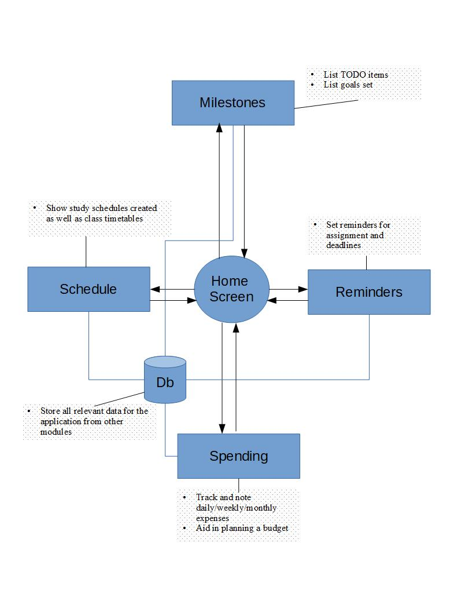The following diagram summarizes how the application will work (at a bare minimum). Not all features may be displayed in the diagram:

Figure : Conceptual Freamework (made with LibreOffice)

CHAPTER 3: RESEARCH METHODOLOGY

* 1. Introduction

The following chapter introduces and discussed the software development methodology to be used to build this project. The methodology will be introduced, stated, discussed and justified as to why it is the preferred choice of methodology over other alternatives

In addition, functional and non-functional requirements will be stated and explained. A table of tools to be used in the development of this project will be listed as well as the various techniques to be used.

Project milestones and deliverables will also be discussed with regards to what is expected of the application. Finally, a Gantt chart will be displayed showing the process of development of the software throughout the duration of the project.

* 1. System Development Methodology

The methodology to be used will be the Prototyping methodology. Specifically, the form of prototyping to be used is the selected features prototyping method. This form of prototyping involves the development of a system in modules (Kendall & Kendall, 2011). The system will be initially built with just a GUI and no functionality. This means that all the features of the project regarding how the user will see the app will be present but without the functionality underlying them (a button on the screen may not be functional at first deployment). As the project develops the different modules will be added on one after the other and tested for functionality. If one module is successfully deployed the next module will be developed. There is no defined order in which the modules are to be built, and most modules will be independent of other modules (few dependencies).

* 1. Justification of the methodology

The main constraint in the development of this project is time. Kendall & Kendall state that the prototyping methodology is advantageous in significantly decreasing the time taken for system analysis. As the project moves along, any errors can be patched and fixed. In addition, a lot of the development is a learning trial-and-error process, as a lot of learning is to be done during project development.

In addition, a lot of emphasis will be put into the user interface and a good UI/UX has been listed as a guideline for prototyping by Kendall & Kendall. The prototype will also address user needs better as improvements can always be made iteratively. System analysis can be carried out throughout the development of the project.

* 1. Functional and Non-functional Requirements

The following are to be the functional requirements of the project:

1. Authentication and Registration of users
2. To provide reminders for students.
3. To list milestones and objectives to be completed.
4. Note daily expenditures and help in calculating a working budget.
5. Create timetables for classes
6. Create study schedules.

Authentication is necessary for security purposes as well as to allow multiple users to separate their data. Reminders will allow students to complete due tasks accordingly. Milestones and objectives will help students in organizing themselves. Expenditure tracking will hopefully help students spend funds more mindfully. Timetables will reduce the need for students to carry around physical copies of the same, hence increasing ease of use. Study schedules will allow students to plan their revision accordingly.

* 1. Tools and techniques to be applied

Table 1: List of tools to be used

|  |  |
| --- | --- |
| TOOL | USE |
| Android Studio | Base IDE for the actual application development. |
| Gimp (v2.10) | To be used to design the background to be used in the application (for the UI) |
| GitHub | To be used as an online repository where the entire project will be stored and used to make edits and back-ups. |
| Inkscape | To be used to design the icon/logo of the application |
| Microsoft Office | To be used for the documentation of the project |
| LibreOffice Draw | To be used to design application functionality and draw the various diagrams |
| Java | The main programming language in use, the backbone of the entire software |

Table 2: List of techniques to be used in this project

|  |  |
| --- | --- |
| TECHNIQUE | USE/REASON |
| Object Oriented Programming Paradigm | Due to the nature of mobile application programming, an OOP approach will be required to be the most heavily used in the development of the software. In addition, the choice of Java as a programming language also implies that an OOP approach will be the primarily taken approach. |

* 1. Project Milestones and Deliverables
* Visualize the project and come up with the concept notes.
* Prepare and submit the proposal for the project.
* Develop the user interface of the project
* Develop the reminders module
* First application test
* Develop the schedule module
* Develop the cost-spending module.
* Second application test
  1. Gantt chart

|  |  |  |  |  |  |  |  |  |  |  |  |  |  |  |
| --- | --- | --- | --- | --- | --- | --- | --- | --- | --- | --- | --- | --- | --- | --- |
|  | Week | | | | | | | | | | | | | |
|  | 1 | 2 | 3 | 4 | 5 | 6 | 7 | 8 | 9 | 10 | 11 | 12 | 13 | 14 |
| Week Start: | 7/5 | 14/5 | 21/5 | 28/5 | 4/6 | 11/6 | 18/6 | 25/6 | 2/7 | 9/7 | 6/7 | 23/7 | 30/7 | 6/8 |
| Documentation: |  |  |  |  |  |  |  |  |  |  |  |  |  |  |
| User interface: |  |  |  |  |  |  |  |  |  |  |  |  |  |  |
| Reminders: |  |  |  |  |  |  |  |  |  |  |  |  |  |  |
| Timetable/  Scheduling: |  |  |  |  |  |  |  |  |  |  |  |  |  |  |
| Database: |  |  |  |  |  |  |  |  |  |  |  |  |  |  |
| Budget: |  |  |  |  |  |  |  |  |  |  |  |  |  |  |

# References

1. Chua, C. (2018, April 25). *8 Reasons You are Not as Productive as You Can Be (and How to Fix Them)*. Retrieved from Lifehack: https://www.lifehack.org/articles/productivity/8-reasons-productive-can-fix.html
2. Computer Hope. (2018, January 24). *What is the most popular operating system?* Retrieved from Computer Hope: https://www.computerhope.com/issues/ch001777.htm
3. DAlessio, F. (2018, May 21). *11 Quick Steps to be a Super Productive Student*. Retrieved from Lifehack: https://www.lifehack.org/articles/productivity/11-quick-steps-super-productive-student.html
4. Duckworth, A. L. (2012). *Self-Discipline Outdoes IQ in predicting Academic Performance of Adolescents.* Pennsylvania: Sage Publications, Inc.
5. Gildred, J. (2018, April 27). *Google Keep Review*. Retrieved from Cloudwards: https://www.cloudwards.net/google-keep-review/
6. Karch, M. (2018, April 16). *Use Google Calendar. Internet Organization Was Never Easier*. Retrieved from Lifewire: https://www.lifewire.com/google-calendar-1616582
7. Kendall & Kendall. (2011). In *System Analysis and Design, 8th Edition* (p. 601). Camden, New Jersey: Prentice Hall.
8. Sabell, H. (2017, June 23). *7 Tips to Increase Your Productivity as a Student*. Retrieved from The College for Adult Learning: https://collegeforadultlearning.edu.au/tips-to-increase-your-productivity/
9. Sexton, Z. (2017, August 1). *Insider Secrets For Organizing Your Life And Boosting Your Productivity With Evernote*. Retrieved from Medium: https://medium.com/@zacharysexton/insider-secrets-for-organizing-your-life-and-boosting-your-productivity-with-evernote-205b1cd7ae61